Properties and Structure of Atoms Test 2017

TIME ALLOWED: 55 MINUTES (55 marks total)

Part A: Multiple Choice Questions. (10 marks)

Q1. The species 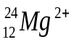 contains

A. 12 protons, 12 neutrons and 12 electrons
B. 12 protons, 12 neutrons and 14 electrons
C. 12 protons, 10 neutrons and 10 electrons
D. 12 protons, 12 neutrons and 10 electrons

Q2. Some information about the element rhenium (Re) is given in the table below.
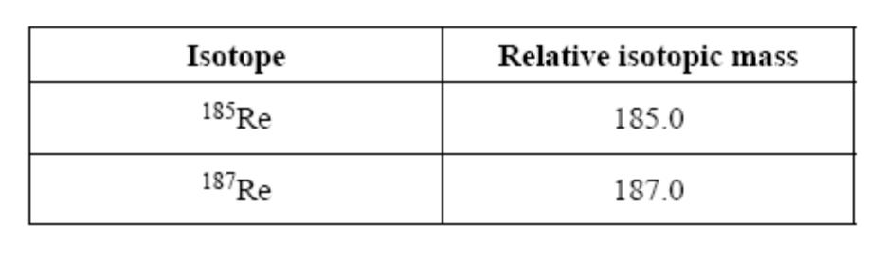
Given that the relative atomic mass of Re is 186.2, the percentage abundance of ¹⁸⁵Re is closest to

A. 40
B. 50
C. 60
D. 70

Q3. A set of isoelectronic ions is:

A. S²⁻, K⁺, Ne, Cl⁻

B. O²⁻, S²⁻, Se²⁻, Te²⁻

C. S²⁻, Ca²⁺, K⁺, Cl⁻

D. Al³⁺, P³⁻, S²⁻, Cl⁻.

Q4. In two species, the first has 29 protons, 29 electrons and 36 neutrons, and the second has 29 protons, 28 electrons, and 36 neutrons.

The two species are:

A. an atom and a cation.

B. an atom and an anion.

C. allotropes of each other.

D. isotopes of each other.

Q5. An element X from group 1 period 3 is…

A. 2, 8, 1
B. 2, 7
C. 2, 5
D. 2, 8

Q6. Which of the following species will be deflected to the greatest extent in a mass spectrometer?

- ¹³⁷A
- ¹³⁵A⁺
- ¹³⁶A⁺
- ¹³⁵A²⁺

Q7. Which statement about Atomic Absorption Spectroscopy (AAS) is correct?

- AAS is an effective qualitative technique but it cannot be used for quantitative analysis
- AAS measures the wavelengths of light emitted when electrons fall back to their ground state
- In AAS, white light is shone through a vaporised sample in order to observe which wavelengths are absorbed
- The wavelength of light used in AAS matches one of the spectral lines produced when the sample is analysed by a flame test

Q8. What is the purpose of the flame in atomic absorption spectroscopy (AAS)?

- To ionise the sample
- To produce a spectrum
- To atomise the substance
- To provide the absorption wavelength

Q9. Which of the following is the reason an atom and its ion have almost the same mass?

- There is no significant difference between and atom and its ion.
- The nucleus of an atom is unaffected when an atom becomes an ion.
- Most atoms have isotopes.
- The mass of an electron is insignificant when compared to the mass of a proton or neutron.

Q10. A positively charged particle with the electron configuration 2, 8 could be:

- a neon atom.
- a sodium atom.
- a fluoride ion.
- a potassium ion.

END OF PART A

PART A

1 | 2 | 3 | 4 | 5 | 6 | 7 | 8 | 9 | 10
D | A | C | A | A | D | D | C | D | B

PART B: SHORT ANSWER QUESTIONS (45 marks)

Q11. Complete the following table:
(i) Name the species.
(ii) Draw electron dot diagrams showing the arrangement of all valence electrons.

SPECIES | NAME OF  SPECIES | ELECTRON DOT DIAGRAM  OR Electron Config
Mg | - Magnesium atom | - 2,8,2
N^{3–} | - Nitride ion | - 2,8
F– | (v) Fluoride ion | (vi) 2,8
Ne | (vii) Neon gas | (viii) 2,8
(8 marks)

Q 12. An ancient mass spectrometer prints out some data in a list instead of a graphical representation. Draw a sketch of what would be observed in a graph showing this data. (3 marks)

Labels on axes [2] (x axis = m/z ratio , y axis = abundance or detection)
1 mark drawn roughly to scale.
m/z ratio | Detection
136⁺ | 80
135⁺ | 2010
134⁺ | 350
133⁺ | 210
132⁺ | 19

Q 13. Complete the following table in the answer booklet (i-viii) (4 marks)

Symbol | Atomic Number | Mass Number | Number of protons | Number of Electrons | Number of Neutrons | Electron Configuration
- Ca | 20 | 40 | - 20 | 20 | - 20 | - 2,8,8,2
²⁴Na⁺ | 11 | - 24 | 11 | (vii) 10 | - 13 | - 2,8

Q 14. a) A sample of Hydrogen exists as a mixture of three isotopes. (3 marks)

mass number 3, relative abundance 0.126 %
mass number 2, relative abundance 0.674 %
mass number 1, relative abundance 99.2 %
Calculate the relative atomic mass of hydrogen to 3 decimal places.
(3 x 0.00126) + (2 x 0.00674) + (1 x 0.992) = 1.00926
b) Define relative atomic mass (1 mark)

Ratio of average mass per atom to the mass of an atom of Carbon-12

Q15. Potassium has a relative atomic mass of 39.113. The mass spectrometer reveals that there are two main isotopes of potassium: ³⁹K and ⁴⁰K.

(a) What is the percentage abundance of each element? (2 marks)

³⁹K = 88.7 %
⁴⁰K = 11.3 %

^{(b)} Complete the table (i-vi) below showing the numbers of sub-atomic particles for an atom of 39K and an ion 40K+
 | ³⁹K | ⁴⁰K⁺
Number of electrons | - 19 | - 18
Number of neutrons | (ii) 20 | - 21
Number of protons | - 19 | - 19
(3 marks)
(c) In the Periodic Table Calcium is in the same period as Potassium.
Why do these elements belong to the same period? (1 mark)
Same number of electron shells [1]
(d) Compare and contrast two isotopes in terms of chemical and physical properties.
(4 marks)
Any isotopes –
same number of protons (1) different number of neutrons ie. Heavier [1] some are radioactive or unstable [1]

same chemical reactivity due to the same number of electrons [1]

Q16.
(a) Explain, in terms of electrons, with a diagram how a flame test works. (2 marks)
CORRECT DIAGRAM [1]
Heat is applied to the sample [extra]
Electrons “transform” specific wavelengths of light to kinetic energy and jump to the next energy level. (become excited) [1]
This energy is then released as a different wavelength of light [1] and is specific to the element as quantum jumps are essential [extra].

(b) Explain the difference between an emission spectra and absorption spectra. (4 marks)

Emission spectra – a sample of atoms absorb energy [1] and excited electrons release/transform their energy into light energy [1]
Absorption spectra – a whole spectrum of light wavelengths are shone on a sample of vapourised atoms that absorb specific wavelengths of light energy. [1] These absorbed wavelengths of light are identified as missing or black marks on the spectrum [1]

Q17. (a) What is electronegativity? (1 mark)
The tendency/ability for an element to attract electrons.

(b) Explain what happens to electronegativity as you go across the Periodic Table, from left to right in the second period? (2 marks)
Electronegativity increases moving left to right [1] due to the increased nuclear charge [1]

(c) Explain in terms of electrostatics, the trend in electronegativity that you stated in part (b).
(2 marks)
The center of each consecutive atom has in increased positive charge due to an increased number of protons in the nucleus. [1]
As a result, it has more affinity to attract electrons. [1]

(d) Define ionisation energy, and explain the trend of the group 2 elements as you go down the group. (3 marks)
Ionisation energy is the energy required to remove one mole of electrons from one mole of an element. (ie from the outermost electron energy levels) [1]
Ionisation energy decreases [1] as you go down group 2 because of electron screening/shielding. This negates the attraction from the increasingly positive nucleus. [1]

(e) Explain what happens to the atomic radius of the elements as you go across period 2.
(2 marks)
Atomic radius decreases as you go across period 2. [1] this is due to the increased nuclear charge pulling on the electrons inwards. [1]

END OF TEST

